Letter a – Flat Hat |  | Name
Directions:  - Use a red crayon to color each letter “a” you can find around Mr. Flat Hat.  - If the letter “a” is not written correctly put an “x” on it. | - Count the red “a’s” you colored. Write this number in the box next to the Crayon People.  - Use a pencil to write the letter “a” inside the hollow letters at the bottom of the paper.  - Write the letter “a” 3 times, starting on each of the last 3 dots.  - You can then color Flat Hat any colors you would like.

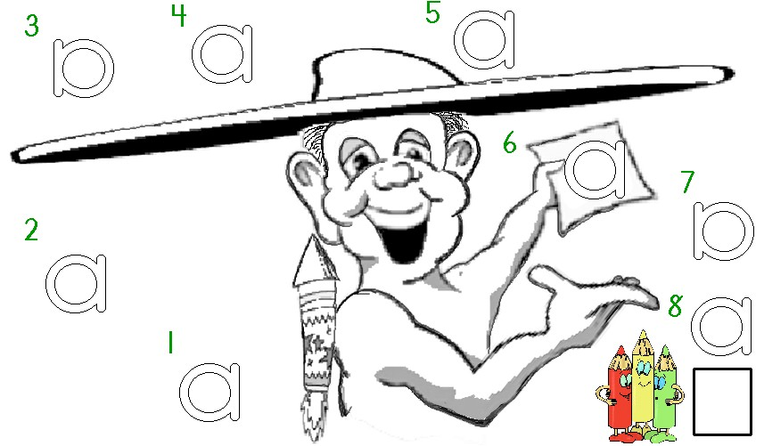

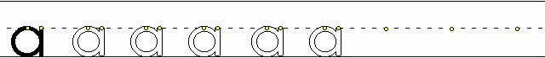
Worksheets available from TampaReads.com

