c – Cool Cat |  | Name
Directions:  - Use an orange crayon to color every letter “c” you can find next to the Cool Cat.  - Any letter that is not “c” – color black.  - Count the orange “c’s.” Write the number in the box next to the Crayon People. | - Use a pencil and write the letter “c” inside the hollow letters at the bottom of the paper.  - Write the letter “c” 3 times, starting on each of the last 3 dots.  - You can then take out more crayons and color the Cool Cat any colors you would like.

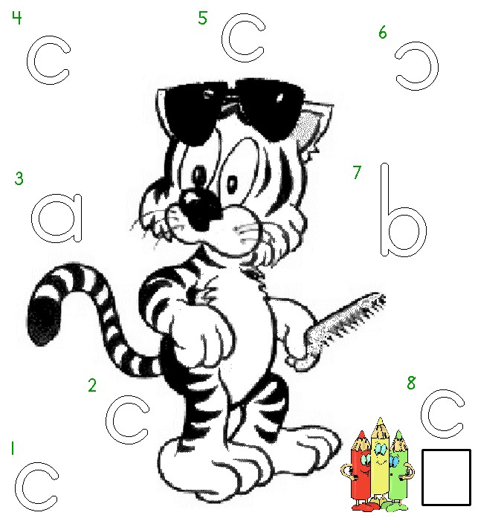

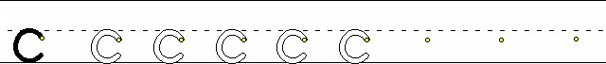
Worksheets available at Tampareads.com

