d – Dancing Dinosaur |  | Name
Directions:  - Use a brown crayon to color every letter “d” you can find next to the Dancing Dinosaur.  - Any letter that is not “d” – color black.  - Count the brown “d’s.” Write the number in the box next to the Crayon People. | - Use a pencil and write the letter “d” inside the hollow letters at the bottom of the paper.  - Write the letter “d” 3 times, starting on each of the last 3 dots.  - You can then take out more crayons and color the Dancing Dinosaur any colors you would like.

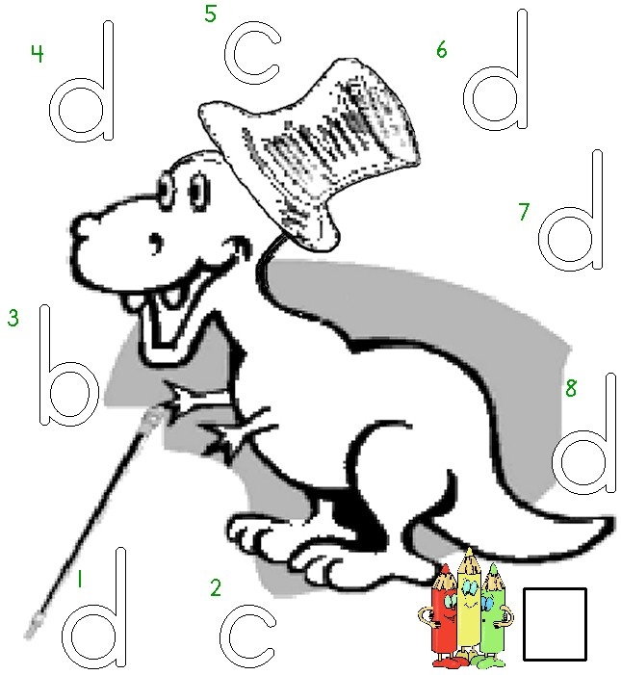

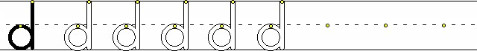
Worksheets available from Tampareads.com and Readingkey.com

