e – Excellent Elephant |  | Name
Directions:  - Use a blue crayon to color every letter “e” you can find next to the Excellent Elephant.  - Any letter that is not “e” – color black.  - Count the blue “e’s.” Write the number in the box next to the Crayon People. | - Use a pencil and write the letter “e” inside the hollow letters at the bottom of the paper.  - Write the letter “e” 3 times, starting on each of the last 3 dots.  - You can then take out more crayons and color the Excellent Elephant any colors you would like.

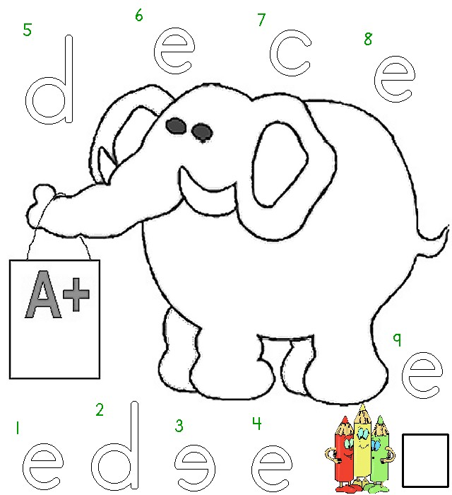


Worksheets available from Tampareads.com and Readingkey.com

