f – Friendly Fish |  | Name
Directions:  - Use a yellow crayon to color every letter “f” you can find next to the Friendly Fish.  - Any letter that is not “f” – color black.  - Count the brown “f’s.” Write the number in the box next to the Crayon People. | - Use a pencil and write the letter “f” inside the hollow letters at the bottom of the paper.  - Write the letter “f” 3 times, starting on each of the last 3 dots.  - You can then take out more crayons and color the Friendly Fish any colors you would like.

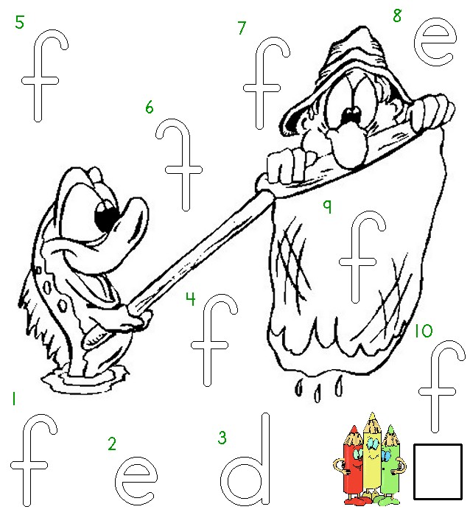

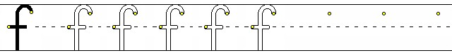
Worksheets available at Tampareads.com

