h – Hairy Horse | Name
Directions:  - Use a red crayon to color every letter “h” you can find next to the Hairy Horse.  - Any letter that is not “h” – color black.  - Count the red “h’s.” Write the number in the box next to the Crayon People. |  | - Use a pencil and write the letter “h” inside the hollow letters at the bottom of the paper.  - Write the letter “h” 3 times, starting on each of the last 3 dots.  - You can then take out more crayons and color Hairy Horse any colors you would like.

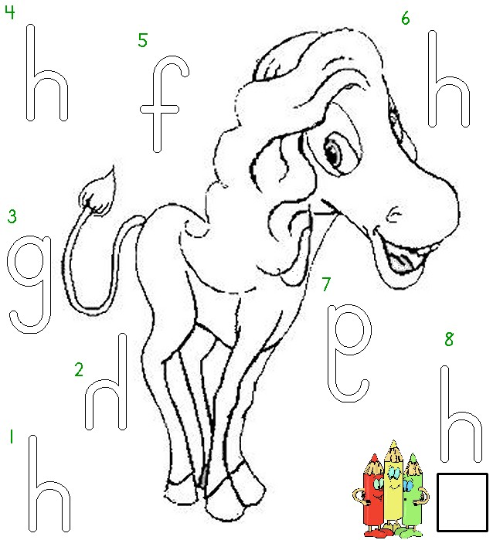


Worksheets available from Tampareads.com

