i – Sid Squid | Name
Directions:  - Use a green crayon to color every letter “i” you can find next to the Sid Squid.  - Any letter that is not “i” – color black.  - Count the green “i’s.” Write the number in the box next to the Crayon People. |  | - Use a pencil and write the letter “i” inside the hollow letters at the bottom of the paper.  - Write the letter “i” 3 times, starting on each of the last 3 dots.  - You can then take out more crayons and color Sid Squid any colors you would like.

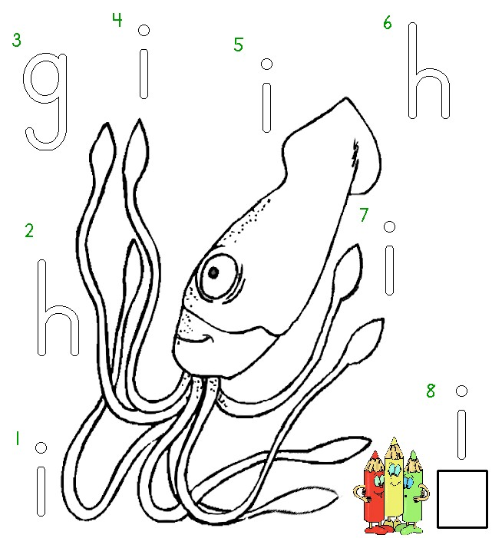


Worksheets available from Tampareads.com

