m – Magic Monster |  | Name
Directions:  - Use a yellow crayon to color every letter “m” you can find next to the Magic Monster.  - Any letter that is not “m” – color black.  - Count the yellow “m’s.” Write the number in the box next to the Crayon People. | - Use a pencil and write the letter “m” inside the hollow letters at the bottom of the paper.  - Write the letter “m” 3 times, starting on each of the last 3 dots.  - You can then take out more crayons and color the Magic Monster any colors you would like.

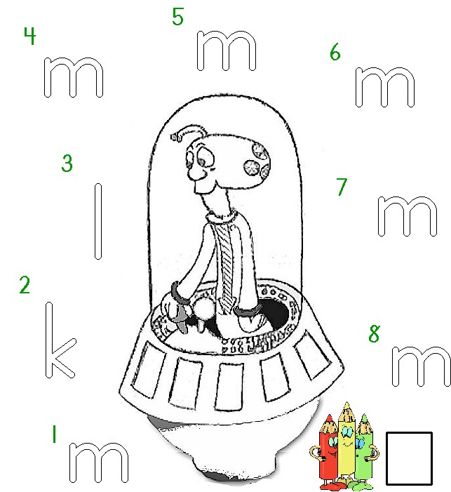

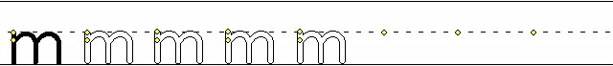
Worksheets available from Tampareads.com

