Trip to Fox Mountain
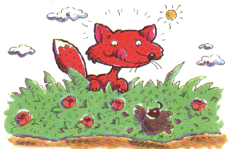
1  23456 |  | I will tell you where you can go to see the red fox.  Yes, this fox is such fun. You will want to see him each day you can.  Yes, each day. |  | 55  56  57  58  59  60 |  | Why it rains the way it does I don’t and won’t say. If you want you can lie in the tub to get off the mud. You don’t want mud on you or your coat.

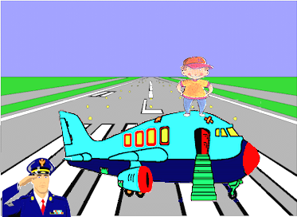 |  |  |  |  | 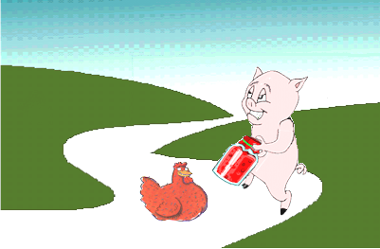
13  14  15  16  17  18 |  |  |  | The fox said he goes far from here. The men said we can go see him in a jet. Come on with us. It will be such fun with the fox. |  |  | 43  44  45  46  47  48 |  |  | Can your arm take the lid off the jam? The pig says he can take it off.  The hen says there is no way for him to do it. What do you say ?
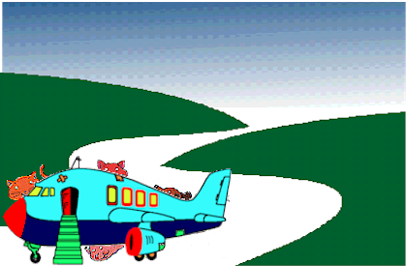 |  |  |  |  |  | 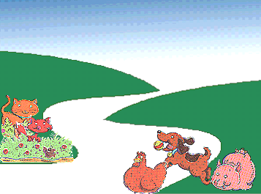
25  26  27  28  29  30 |  |  | I have got to tell you what to do when your jet gets there on the long road. You have to eat  the red jam. Do you like to eat red jam ? We do. |  |  |  |  | 31  32  33  34  35  36 |  | On the road with the fox there is a pig, a dog,  a cat and a hen.  The pig will tell you where to eat the jam.  Yes, you can do it.

