Vowel  Sounds: |  |  | a – e – i- o – u  ea - ay |  | Vowel  Sounds: |  |  |  |  | e – i – o – u  a – e – oa – ee - y
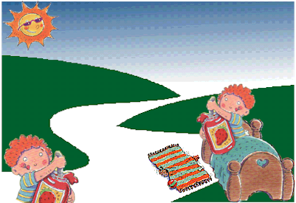
37  38  39  40  41  42 |  | Do you want to eat your jam in the hot sun or do you want to eat your jam on top of the bed or on the rug?  Well, what do you say? |  |  |  | 19  20  21  22  23  24 |  |  | When we get in the jet with the men it will take us up on top of the long road. You will see why the fox does like it where  he is.
Vowel  Sounds: |  |  |  | e – i – o – u  ai – ea – oa – ay – ee |  |  | Vowel  Sounds: |  |  |  | a – e – I – o  a – e - ay - ee
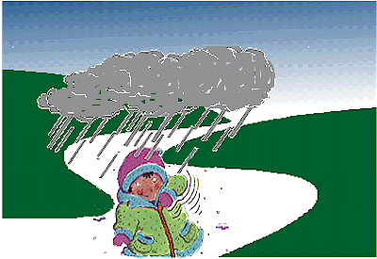 |  |  |  |  | 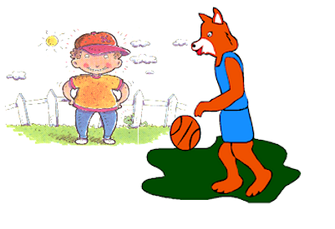
49  50  51  52  53  54 |  | The rain will come each day when it gets dark.  It will rain long so zip up your coat when you see the rain come. We don’ t want it to rain here. |  |  |  | 7  8  9  10  11  12 |  |  | What can you say to such a fun fox?  You can tell him your name or you can tell him you want to see where he is.

Vowel Sounds: |  |  | a – o – i – u  o – e  ow – oo – or (New Sounds Next Book) | by Tampareads.com  Book #1: Children should attempt Trip to Fox Mountain only when words from Levels 1-10 Grade 1 Reading Vocabulary have been practiced (i.e. word wall – worksheets - or vocabulary list). This is because Trip to Fox Mountain has been written using only these 100 words (plus 10 of our CVC nouns). This concentrated review results in a powerful tool for helping to solidify these words into the child’s long term memory. However, this vocabulary restriction at times results in somewhat awkward sounding sentences and wording so please be forgiving and keep in mind the reason for this. Each vocabulary word also appears at least 3 times in the story and in a certain sequence to further facilitate memorization. To help children with decoding (sounding out) words, remember, short vowels are red – long are blue and the “other” vowel sounds (r-controlled – digraphs) are green.
61  62  63  64  65  66 |  | Oh no, we have to go.  The fox says he will see you not long from now. We can soon ride the bus to the zoo and have a lot more fun.

