Alphabet Cartoon Characters
Letter Memorizing Sheets

1st Step  in Learning to Read  Research from the National Institute of Health recently stated that one of the best predictors of future reading success was having the names of the alphabet letters memorized. This should be no surprise. If the name of the letter is memorized by the child, then memorization of the sound is right around the corner. In fact, the sound made by most letter names can be heard when you say the letter name. This could be either at the beginning of the letter name (b – d – j – k – p – t – v – z) or heard at the end of the letter name (f – l – m – n – r – s – x). This is one reason why it makes sense to learn the letter names before learning the letter sound or at least at the same time. Memorization of any new material is accelerated greatly if the information being given is viewed by a child as “fun” – “humorous” – or “unique.” Our 26 Alphabet Letter Characters qualify on all three counts.  HOW TO USE THE  ALPHABET LETTER SHEETS  There are several ways you can use  the alphabet letter sheets:  - Place all the letters on a wall in the classroom or (for home school parents) place 4 or 5 along the wall in the child’s bedroom or “living room.” Classroom teachers should put the uppercase letters on one wall and the lowercase letters on another wall.  - If you like to place extra emphasis on one alphabet letter per week (which can be advantageous in a public school Kindergarten class), then print out 4 or 5 additional copies of the week’s letter sheet and place in strategic locations around the class and school (i.e. even the kindergarten lunchroom area).  - For additional practice with the alphabet letter, try our alphabet letter writing activity that has a black and white version of each cartoon character for coloring. An excellent morning “desk-work” assignment could be to have students color the alphabet character and letter as well. If this was a daily assignment for the 5 days in the week you’ll most likely find 99% of your students have a good grasp of the letter name by the end of the week. | A Powerful Game for Teaching the Alphabet Letters  - Using a yardstick as a pointer – teach 3 letters from the list of alphabet cartoon characters on the wall.  - Ask the class to tell you which alphabet cartoon character is on the page of (for example) – letter d.  Their answer would be “Dancing Dinosaur.”  You can see in this case that we are reminding the student of the letter name – and forcing them to use the skill of searching through the list of letter sheets to match this letter name with the cartoon character.  This is an example of the memorizing trick known as “recognition memory” (remember – you taught them the letter first, and then reminded them of the letter name again). Recognition Memory is extremely effective for the first step in memorizing any new information.  When teaching new information - it is essential that it be introduced in small amounts and practiced repeatedly for enhancing memorization.  HOW TO PRINT THE  ALPHABET LETTER SHEETS  To print the 26 alphabet letter character sheets in this section for PC computers click the <PRINT> icon on the toolbar or click File from the top left of the screen – then click Print.  If you would like to print only 1 letter page you can click on the page you want (to put the cursor on the page) and then select the “Current Page” option from the print options box.

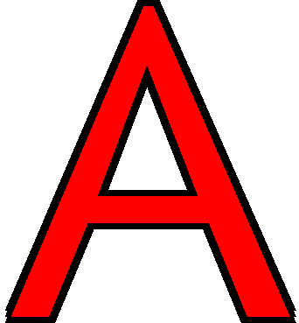

Flat Hat



Baseball Bee


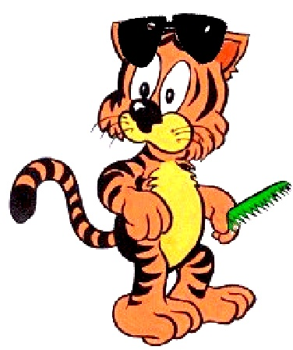

Cool Cat




Dancing Dinosaur




Excellent Elephant



Friendly Fish




Gorilla Girl



Hairy Horse



Sid Squid


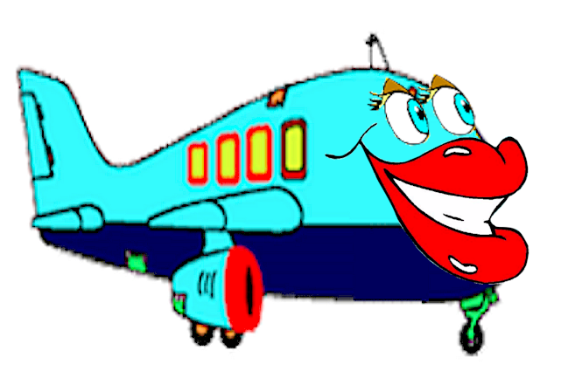

Jolly Jet



Kind Kangaroos

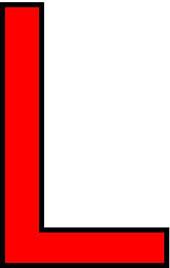


Lazy Lion

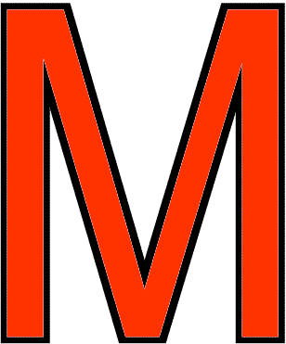
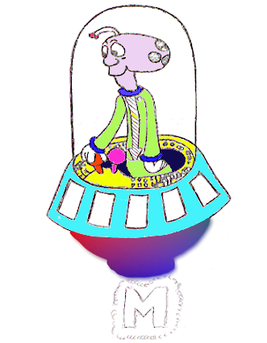

Magic Monster

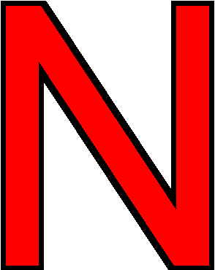

Necktie Ned


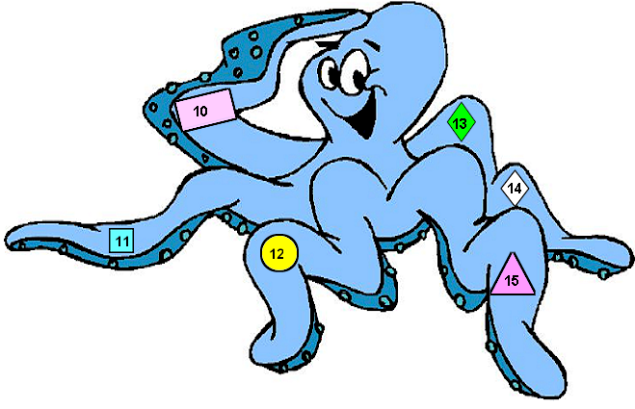

Odd Octopus



Purple Parrot

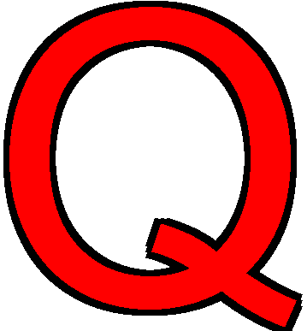


Quiet Queen



Racing Rabbit




Super School



Tattle Tale Turtle




Umbrella Fella




Violin Vegees


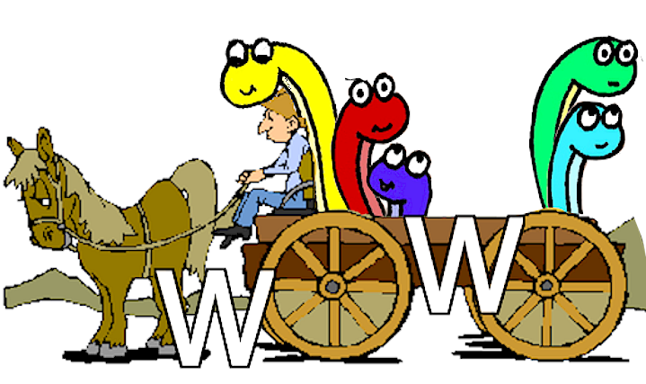

Worm Wagon



Fox Box

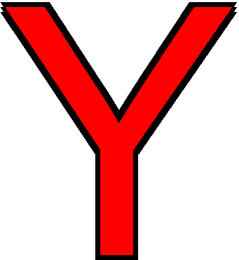
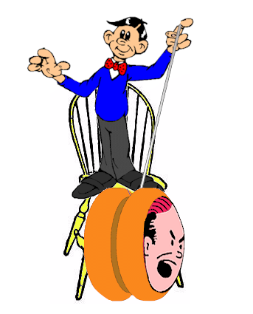

Yelling Yo-Yo


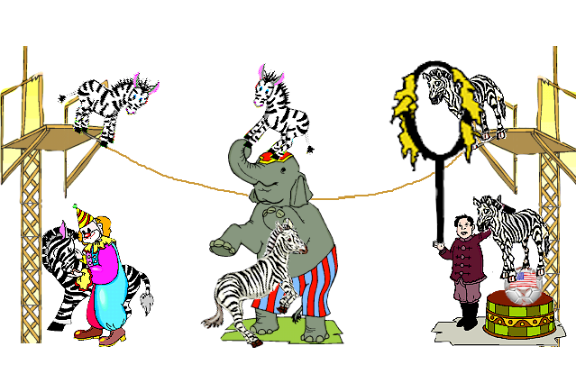

Zebra Zoo

